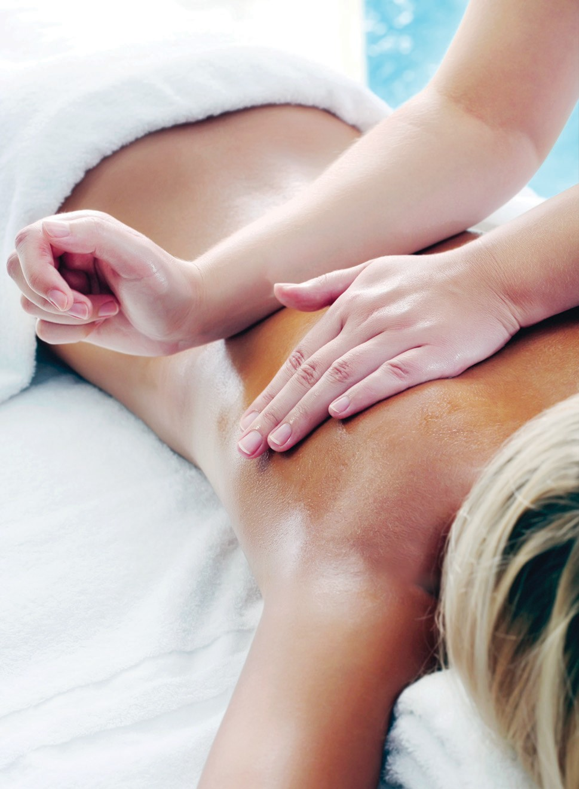Our aim is to rebalance and rejuvenate, helping you feel and look your best every day. Every treatment is customised to achieve optimal results.

All treatments are performed in our Mysa Salon and Spa, each student is developing their treatment skills while being supervised by the salon manager and teacher.

We use a number of professional product ranges, please talk to your beauty therapist to discuss the best treatments and products for you.

**mysa [ mē΄sah ]**

orig. Sweden

# verb

To be engaged in an activity that’s pleasurable and relaxing.

# adjective

Cozy, comfortable.

# noun

Contentment.

# Berwick

Building K, Level 3 25 Kangan Drive, Berwick. Call **03 9212 4702** for salon operating hours.

# Frankston

Mysa Salon and Spa

Building A, Level 1 Fletcher Road, Frankston. Monday to Friday 9am – 4pm

Call **03 9238 8585** for salon operating hours.

All Chisholm salons and spas operate during the Victorian school term and bookings are by appointment only.

BEAUTY PRICELIST

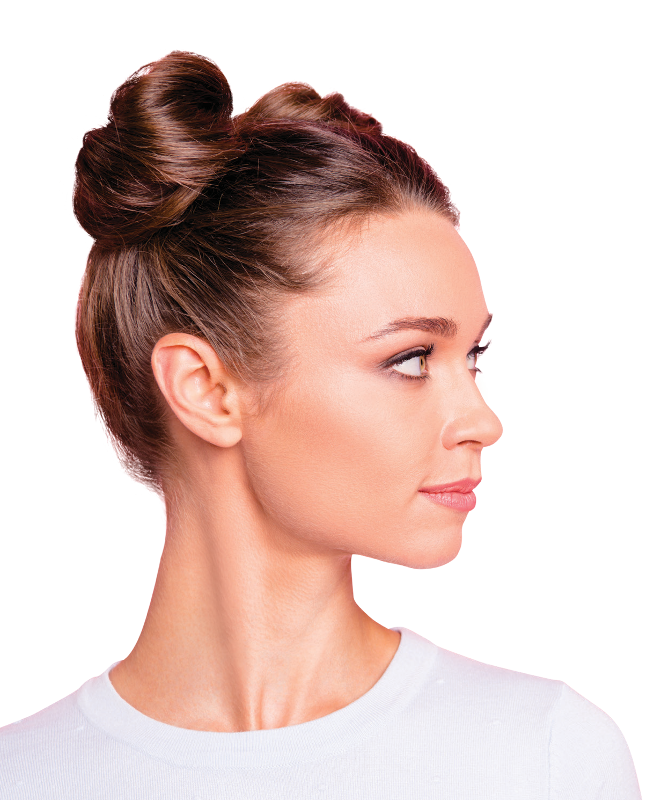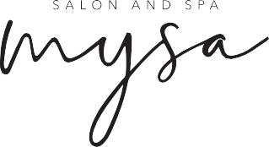

2346_0721 CRICOS No 00881F RTO No 0260 TEQSA PRV12123.

BEAUTY PRICELIST

**MASSAGE**

|  |  |
| --- | --- |
| **WAXING AND TINTING** | |
| **½ leg** | $15 |
| **Full leg** | $20 |
| **Bikini** | $10 |
| **Brazilian** | $20 |
| **½ arm** | $10 |
| **Full arm** | $15 |
| **Under arm** | $5 |
| **Eyebrow** | $5 |
| **Lip** | $5 |
| **Chin** | $5 |
| **Sides of the face** | $5 |
| **Full face** | $15 |
| **Lash tint** | $8 |
| **Brow tint** | $5 |
| **Lash and brow tint** | $10 |

|  |  |
| --- | --- |
| **Relaxation massage,** (60mins) | $25 |
| **Hot stone massage,** (60mins) | $30 |
| **Aroma massage,** (60mins) | $30 |
| **Indian head massage,** (30mins) | $15 |
| **Reflexology,** (40mins) | $15 |

**BODY TREATMENTS**

|  |  |
| --- | --- |
| **Dry room body wrap (detoxing or hydrating),**  (1hr 45mins) | $35 |
| **Wet room body wrap,** (1hr 45mins) | $45 |
| **Cellulite zone treatment,** (45mins) | $20 |
| **Zone firming treatment,** (30mins) | $15 |
| **Salt glow,** (45mins) | $20 |
| **Body wrap,** (90mins) | $40 |
| **Back facial,** (1hr) | $25 |

**BODY TREATMENT ADD-ON**

|  |  |
| --- | --- |
| **MAKE-UP AND NAILS** | |
| **Day make-up** | $15 |
| **Evening make-up** | $20 |
| **Special occasion make-up** | $25 |
| **Express manicure** | $10 |
| **Express pedicure** | $10 |
| **Spa manicure** | $20 |
| **Spa pedicure** | $20 |

Customise your body treatment by adding one of our hydrotherapy treatments.

|  |  |
| --- | --- |
| **Spa capsule treatment** | $15 |
| **Spa tub soak** | $10 |

**FACIALS**

A skin analysis and consultation is performed at the beginning of every facial to determine the correct products and treatment plan to deliver your desired results.

|  |  |
| --- | --- |
| **Signature facial,** (60mins) | $25 |
| **Anti-aging facial,** (60mins) | $30 |
| **MediBac facial,** (60mins) | $30 |
| **Ultra calming facial,** (60mins) | $30 |

**FACIAL ADD-ON**

Customise your facial by adding one of our advanced treatments.

|  |  |
| --- | --- |
| **Galvanic treatment,** (10mins) | $5 |
| **High frequency,** (10mins) | $5 |
| **Ultrasonic,** (10mins) | $5 |
| **Micro-lift,** (10mins) | $5 |

Making your appointment.

Our Mysa Salon and Spa currently operates on selected days during the week. If we are unable to answer your call, please leave a message with your name and contact number and we shall return your call as soon as possible.

Please arrive 10 minutes prior to your appointment to complete your client card and to enjoy a freshly boiled cup of tea.

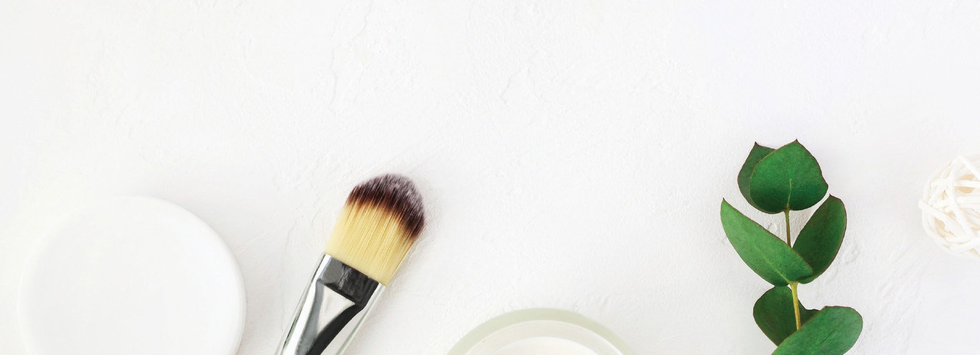

**HYDROTHERAPY**

|  |  |
| --- | --- |
| **Customised spa hydrotherapy treatment** | $40 |

**Please note:** All students are required to provide product information, treatment plans and after care advice as part of their practical assessments.

Thinking about studying Beauty Therapy? Visit **chisholm.edu.au**