* 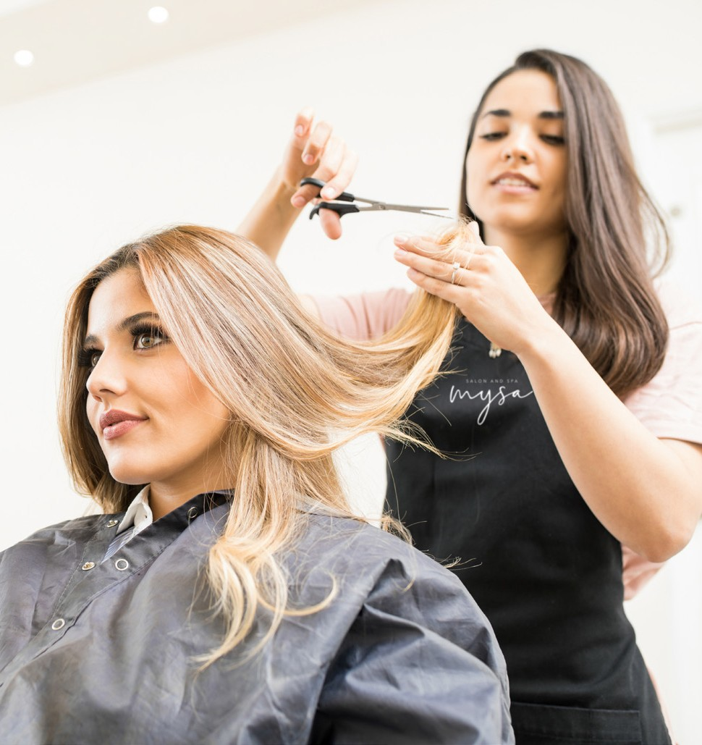Upon your visit, the student will conduct a ‘consultation’ to evaluate the hair for the service and quote the cost of the service.
* The student will them escort you to reception to pay for your service.
* Your consultation outcome and service will be monitored continually by the Educator.
* Please allow more time than usual for your service to be completed as our students are being assessed step by step.

Thank you for supporting our students in their training.

**mysa [ mē΄sah ]**

orig. Sweden

# verb

To be engaged in an activity that’s pleasurable and relaxing.

# adjective

Cozy, comfortable.

# noun

Contentment.

# Berwick

Building K, Level 3 25 Kangan Drive, Berwick. Call **03 9212 4702** for salon operating hours.

# Frankston

Mysa Salon and Spa

Building A, Level 1 Fletcher Road, Frankston. Monday to Friday 9am – 4pm

Call **03 9238 8585** for salon operating hours.

All Chisholm salons and spas operate during the Victorian school term and bookings are by appointment only.

HAIRDRESSING AND BARBERING PRICELIST

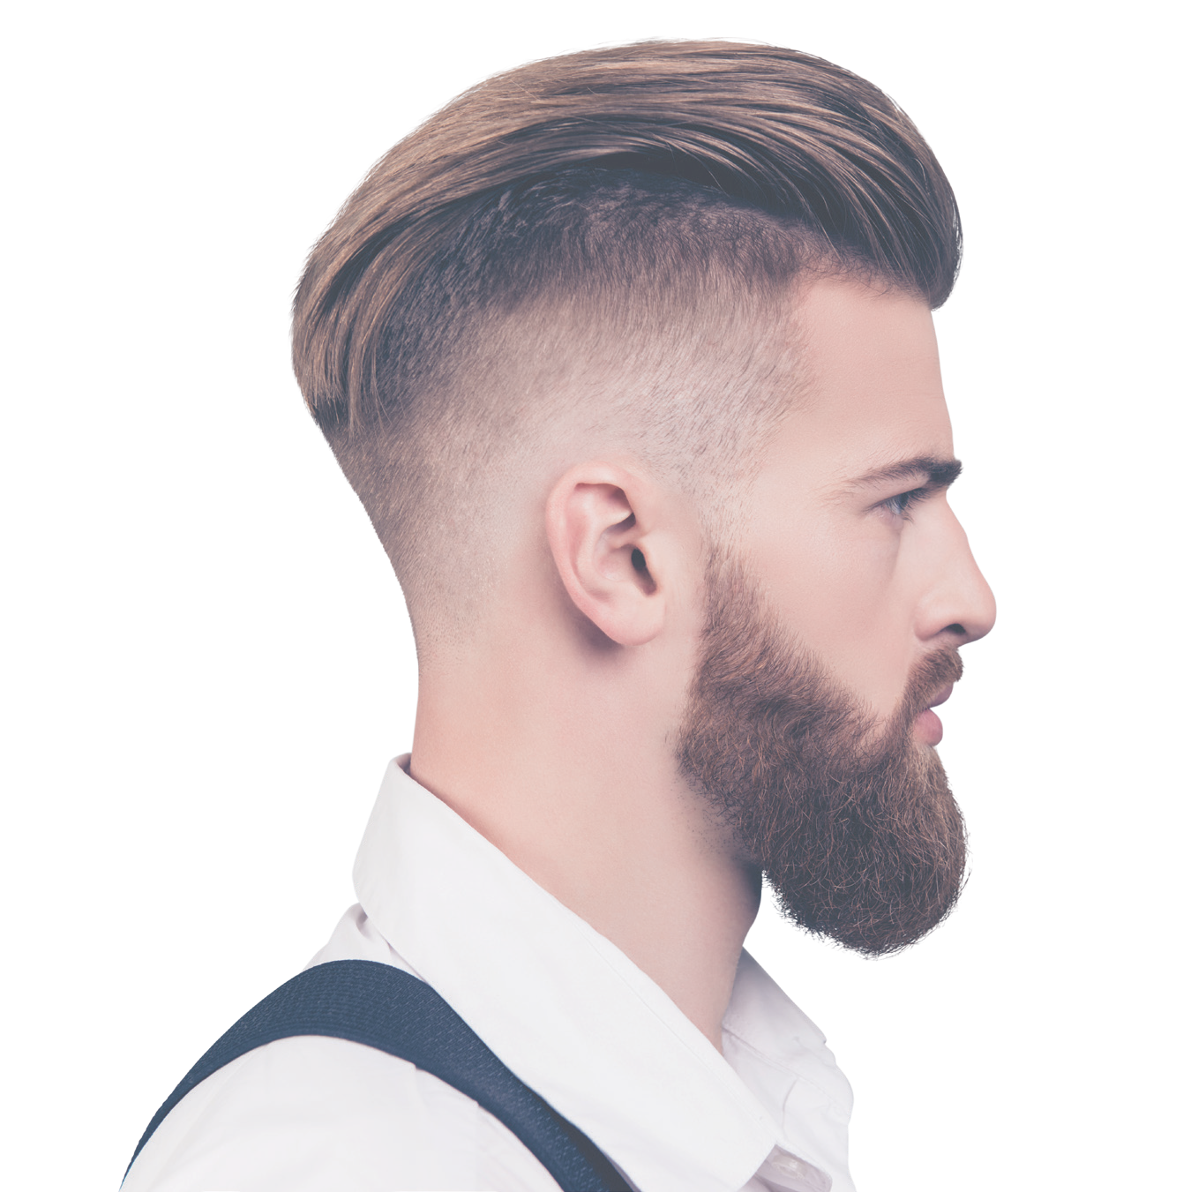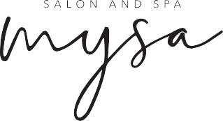

2346_0919 CRICOS No 00881F RTO No 0260

Thinking about studying Hairdressing? Visit **chisholm.edu.au**

HAIRDRESSING PRICELIST

|  |  |  |
| --- | --- | --- |
| **STRAIGHTENING** | **PRICE** | **PENSION DISCOUNT** |
| **Long** | $60–$80 | $60 |
| **Medium** | $50–$70 | $50 |
| **Shor**t | $40–$50 | $30–$40 |

**BARBERING PRICE**

|  |  |  |  |
| --- | --- | --- | --- |
| **CUTTING AND STYLING** | **HAIR LENGTH** | **PRICE** | **PENSION DISCOUNT** |
| **Ladies cut and style** | N/A | $12 | $10 |
| **Mens cut and style** | N/A | $10 | $8 |
| **Blow wave/set** | N/A | $10 | $10 |
| **Conditioning treatment** | N/A | $8 | $8 |

|  |  |  |  |
| --- | --- | --- | --- |
| **BASIC COLOUR** | **HAIR LENGTH** | **PRICE** | **PENSION DISCOUNT** |
| **Permanent** | Long | $45 | $30 |
| Medium | $35 | $25 |
| Short | $25 | $20 |
|  | | | |
| **Semi** | Long | $35 | $25 |
| Medium | $25 | $15 |
| Short | $15 | $10 |
| **COLOUR AND FOILS** | **HAIR LENGTH** | **PRICE** | **PENSION DISCOUNT** |
| **Colour and full head of foils** | Long | $65 | $55 |
| **Colour and half head of foils** | Medium | $55 | $45 |
| **Colour and quarter head of foils** | Short | $45 | $35 |
| **Colour and 5-10 splices** |  | $25 | $15 |

**PENSION DISCOUNT**

|  |  |  |
| --- | --- | --- |
| **Style cut** | $10 | $8 |

**SPECIALISED SERVICES**

|  |  |  |
| --- | --- | --- |
| **FOILS - FULL HEAD** | **PRICE** | **PENSION DISCOUNT** |
| **Long** | $55 | $45 |
| **Medium** | $45 | $35 |
| **Short** | $35 | $25 |
| **FOILS - HALF HEAD** | **PRICE** | **PENSION DISCOUNT** |
| **Long** | $45 | $35 |
| **Medium** | $35 | $30 |
| **Short** | $25 | $15 |
| **FOILS - QUARTER HEAD** | **PRICE** | **PENSION DISCOUNT** |
| **Long** | $35 | $25 |
| **Medium** | $30 | $20 |
| **Short** | $20 | $10 |

|  |  |  |
| --- | --- | --- |
| **Fades** | $15 |  |
| **Clean head shave** | $10 |  |
| **Tracks and carving designs** | $10 – $15 |  |
| **Clean face shave** | $10 |  |

# Brow, nose, ear trim

(complimentary with barbering service)

**Long** - past shoulders, **Medium** - on or just above shoulder,

**Short** - neck/nape length

\***Please note**, prices are subject to change depending on the outcome of client consultation and inflation of stock prices.

|  |  |  |
| --- | --- | --- |
| **SCALP BLEACH AND TONER** | **PRICE** | **PENSION DISCOUNT** |
| **Long** | $65 | $55 |
| **Medium** | $55 | $45 |
| **Short** | $45 | $35 |

**Important notes:**

* + Under no circumstances will we tolerate inappropriate behaviour towards any student or staff member. If this behaviour takes place, the service will immediately end and the customer will be asked to leave. All Chisholm staff have a duty of care policy regarding students on campus and have the right to refuse any further bookings
  + If you are not happy during or upon completion of your service, please advise the Educator immediately
  + No refunds will be issued for chemical services unless agreed upon by the Educator at completion of the service
  + If you find you are not happy with your service once leaving the salon, you must contact us within one week of your visit.