

Applicant Information Sheet – Literacy and Numeracy Profiling Tool

Step 1
- Open and complete Pre-Training Review (PTR) Form emailed.

Step 2
- Access Language, Literacy and Numeracy (LLN) Profiling Tool by clicking the link provided on the Pre-Training Review Form.
- Login to complete the Language, Literacy and Numeracy (LLN) profile by using the credentials provided in the email.
  - Enter username and password provided in the email.
  - Click on “View Profile” on the top right hand side of the screen.
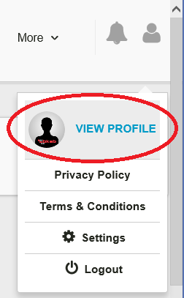
  - Update and Save DOB and Email address
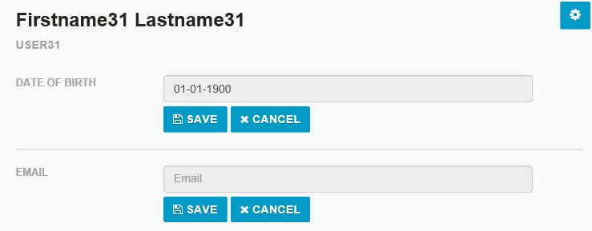
- Complete Profile.
- Once the Numeracy Profile is completed, click button on the top right hand corner of the screen to sit for the Literacy Profile.

Step 3
Print profile results “Language, Literacy and Numeracy (LLN)”
- Once all profiles are completed click button appearing on the top right hand side of the screen
- Click on the completed profiles and print results for both literacy and numeracy profiles. (See screenshot below)
Eg:
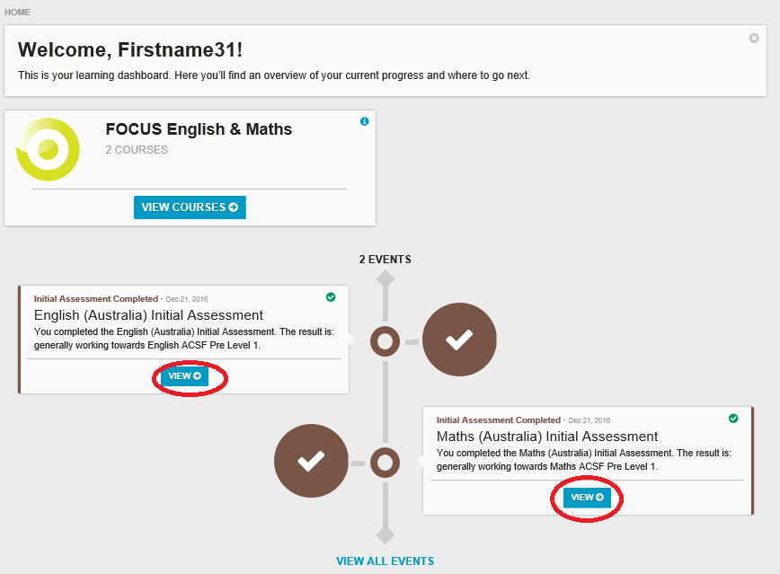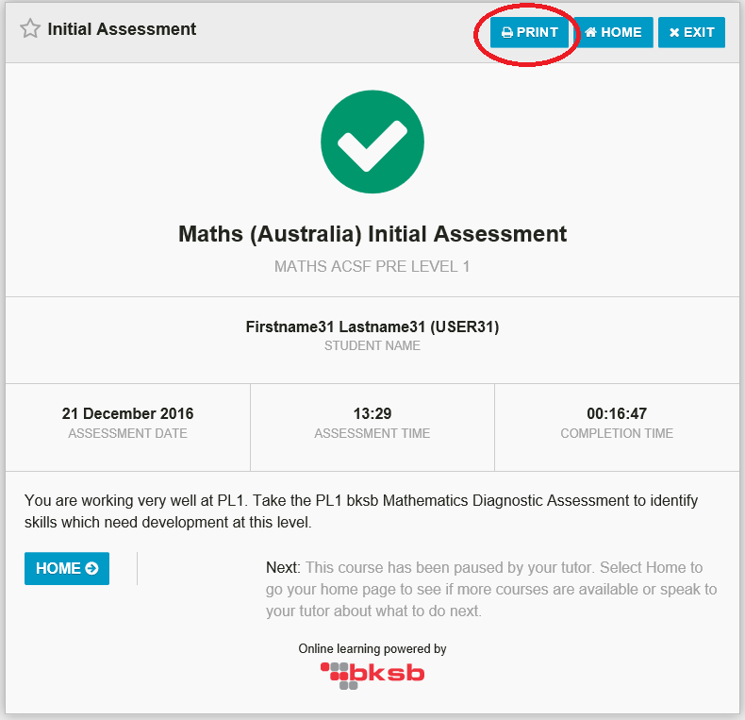

Step 4
Print completed Pre-Training Review (PTR) form

Step 5
Please bring Profile Results Sheet and Pre-Training Review (PTR) form to your enrolment session.

